Ely St John’s Calculation Policy (2020)

Calculation at Ely St John’s is part of the study of mathematics and includes mental and written methods, both formal and informal. Mental calculation and written calculation should complement one another and children are encouraged to talk about their calculation methods in maths and understand the need for efficient approaches.

Children, in both key stages, are encouraged to use “Build it/ Draw it/Write it/ Say it”. This means they will:

- use real life examples where appropriate and handle concrete manipulatives which they can move around
  - e.g. measuring bottles of liquids, weighing vegetables, counting conkers, dividing chocolate bars, using counters, fraction models etc

  - 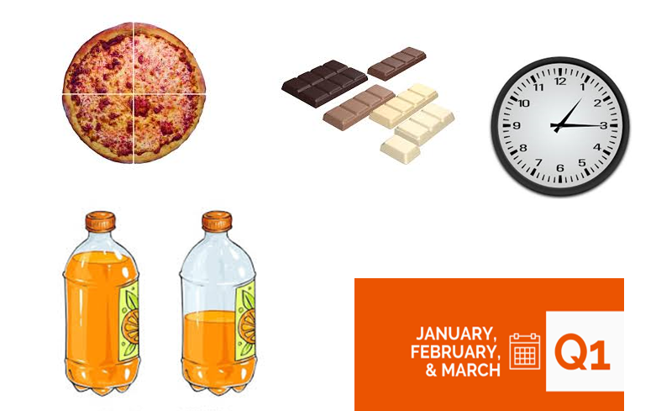

- draw pictures, use words and symbols to represent numerical activities
  - E.g. Pictures of conkers and chocolate bars, digits and numbers
  - Children should be encouraged to represent real things and concrete examples in drawings and jottings to make the link between the concrete and the abstract

- make informal jottings and write procedures, use standard symbols and standard conventions
  - Informal thought waves, number lines,
  - Operations + - x formal written methods

- talk about their reasoning and explain and justify their ideas; make conjectures and predictions and find patterns.

Children are encouraged to refine their approaches to develop efficient methods. They may need to use a detailed inefficient method first and then move to a more efficient method later. For example, 50 divide by 5: take away groups of 5 from 50 to show 10 groups of 5; drawing rows of crosses to divide by 5 in order to understand what is happening when grouping to divide.

Children are shown different ways of doing things and encouraged to be flexible in their approaches.

Children need to progress through:

Counting and acquiring the language of counting

1,2,3,4,5,6 20,19,18,17…… counting in twos, count back in hundreds, increase decrease…

Learning patterns e.g. doubles, 2 4 6 8…, 10 20 30 40 …, 11 21 31 41 51 61 …,

Establishing mental approaches to calculation based on place value.

The following sections are separated out for ease of description but we need to make the links between the different forms of calculation. Addition and subtraction are inverse procedures and can be used to check calculations. E.g. If we know that 5+8=13, then we also know that 8+5=13, that13-5=8 and also13-8=5

Multiplication and division are inverse procedures and we use the idea of switchers and fact families in CLIC to support this idea.
Eg. 7x8=56 8x7=56 56 ÷ 7=8 56 ÷ 8=7

Addition

We teach a range of mental strategies to pupils.

At Key Stage 1 children learn number bonds of 10, e.g 6 + 4 = 10, 5 +5= 10 ; 16+4=20 15+5=20 and bonds within 10: 1+3=4, 2+2=4 3+1=4 etc
Children will see different representations of these relationships.

Children learn to partition number e.g. 7 is 5+2, 3+4, 6+1. This then enables children to add on bridging through 10. E.g. 5+7 = 5+5+2=10+2=12.

Children see different representations to show partition.
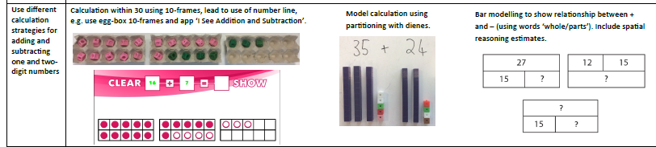

They need to see number sentences as equations where the different amounts on either side of the equals sign are the same.
e.g. 12 = 3+9 9+3 = 12 14 = 8+2+4 15= 20-5 20-5=15

Strategies for teaching mental addition include:

* Putting the largest number first:
6 + 32 is the same as 32 + 6. Start at 32 and count on in ones.

* Partitioning:
(When we partition a number, we split it in to tens and ones so 24 becomes 20 + 4.)

24 + 13 = (20 + 4) + (10 + 3)
20 + 10 = 30
4 + 3 = 7
The answer is 37

Reordering numbers
15+9+11
9+11=20 then add 15

* Compensation:
14 + 9 is the same as 14 + 10 – 1
14 + 9 = 23
27 + 11 is the same as 27 + 10 + 1
27 + 11 = 38

* Doubles or near doubles:
7 + 7 = 14
6 + 7 = 6 + 6 + 1

* Bridging through 10, 20, etc.
8 + 7 = 8 + 2 + 5
= 10 + 5
= 15

Progression from mental to written methods

When children can no longer do a calculation in their head, they are encouraged to do informal jottings. These are not formal methods to use as procedures.

Children might use number lines or ‘thought waves’. They are used to support mental calculations and do not need to be drawn with a rule or drawn to scale. The children may need to make several smaller jumps and then move on to make fewer jumps.

57 + 32 =

10 10 10 2
_____________________________________________________

57 67 77 87 89

3 10 10 9
_____________________________________________________

57 60 70 80 89

(Avoid adding an operation on the jumps and then children can add or subtract and go either way.)

Children are shown an ‘expanded’ method which precedes the formal written method.
We encourage children to add ones first.
We encourage children to use tens and ones materials to help them to complete the task physically. They are encouraged to draw the tens and ones so they have a representation to support the move from the concrete to the more abstract.

48
+ 27
15 (8 + 7)
60 (40 + 20)
75

228
+ 247
15 (8 + 7) adding the ones then the tens then the hundreds
60 (20 + 40)
400 (200 + 200)
475

This leads on to the formal written method.

Step 1: no exchange

3 2 4 1
+ 2 6 3 5
5 8 7 6

Step 2: exchanging and regrouping in the tens column

5 4 8
+ 3 2 7
8 7 5
1

Step 3: exchanging in the hundreds column

5 4 2
+ 3 8 6
9 2 8
1

Step 4: exchanging in the thousands column

2 5 4 2
+ 3 8 5 4
6 3 9 6
1

Step 5: exchanging in more than one column

2 5 4 8
+ 3 8 2 4
6 3 7 2
1 1
Children need to reason about addition and use these approaches in a range of contexts e.g. money, measurements, statistics, angles, fractions etc.

Subtraction
In KS1, children need to subtract by physically taking items away and counting what is left. They need to add the items they took away back to the number left in order to find that they have the number they started with.
Children gradually move from counting to calculating. Children should link subtraction to addition in their representations of the number bond work:
e.g. 6+4=10 10-4=6 10-6=4 (see above in addition)

Strategies for teaching mental subtraction include:

* Putting the largest number first: I had 32 sheep in a field and 6 escaped. How many were left? Start with the flock of 32.
32-6 =26

* Partitioning:
(When we partition a number, we split it in to tens and ones so 24 becomes 20 + 4.)

24 -14= 10 24 -10=14; 14-4=10

* Compensation:
14 - 9 is the same as 14 -10 then + 1 to compensate 14-10=4. 4+1=5
14 - 9 = 5

* Bridging through 10, 20, etc.
e.g. the calculation 17- 8 = 9 can be thought of 17 minus 7 and then subtract 1 more, in effect, count back from 17 to ten and then count back 1 more.

Once again, informal jottings are used before the standard written method is shown, to support mental calculations. These are not formal written procedures. Children might represent the counting steps they make in different ways:

For example: 45 – 17 = 28

Count back:

10 5 2
______________________________________
⎢ ⎢ ⎢ ⎢
45 35 30 28

____5 ___10___ ____ 2__________________
⎢ ⎢ ⎢ ⎢
45 40 30 28

Again, as we head towards the formal written method, we look at an ‘expanded’ form of subtraction and use tens and ones materials to help the children to complete the task physically. They are encouraged to draw the tens and ones so they have a representation to support the move form concrete to abstract.

Step 1: the numbers in the top row are always bigger than the numbers in the bottom row. Start with the ones.

479 – 153 =

4 7 9 _ 400 70 9 _
1 5 3 100 50 3
300 20 6

– 530 – 500 30 9
238 200 30 8

Step 2: moving a ten from the tens column to the ones column

476 – 129 =

6
4 7 16 400 60 16 we cannot subtract the ones
– 1 2 9 – 100 20 9 (without using negative numbers)
3 4 7 300 40 7 so we partition the 70 into 60 + 10
and exchange the 10 for 10 ones. These then move t the ones column.

Step 3: moving a hundred from the hundred column to the tens column

679 – 184 =

6 17 9 500 170 9 we partition the 600 into 500 + 100
– 1 8 4 – 100 80 4 and move the 100 into the tens
4 9 5 400 90 5 column.

This leads to the competent use of the standard written method, where the tens are exchanged for ones and the hundreds exchanged for tens and so on.

3 16
4 7 18
– 1 8 9
2 8 9

Multiplication
To begin with, children put objects into groups or sets and they explore counting multiple groups of the same amount or number.
They then make the connection between repeated addition and multiplication and look at arrays.

Repeated addition

5 + 5 + 5 = 5 x 3 (this is 5, three times)

An array

X X X X 4 x 2 or 2 x 4
X X X X

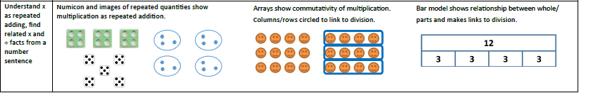

The commutative law

a x b = b x a
6 x 3 = 3 x 6

Children learn multiplication facts through the CLIC programme, from doubles, counting in 2 5 and 10 in KS1 and they then learn up to 12x12 by the end of year 4. Children learn multiplication and division facts as “Learn its” and know them “like they know their names.”
Children learn the multiples in order and link them to division facts through the learning of fact families (CLIC 3x4=12 4x3=12 12÷3=4 12÷4=3)

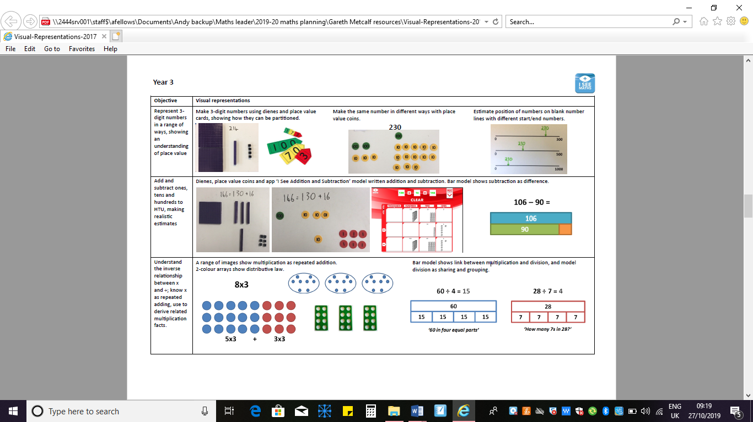

For multiplication of multiples of 10, children use “Smile” multiplication in CLIC. For example, 30x5=150 because 3x5=15 and then this is multiplied by ten. The 3 and 5 are linked with a curved line underneath (a smile!) and children learn to calculate the tables bit first, then multiply by ten.

For multiplication calculation beyond 12 x 12, we initially use the grid method (also called area model) to multiply initially and then the column method to add up.

Example 1: 29 x 8 = 232

x 20 9 160
+ 72
8 160 72 232
1

Example 2: 36 x 24 = 864

x 30 6 600
120
20 600 120 + 120
24
4 120 24 864

Next we make the link between the grid method and short multiplication.

Step 1: no exchange

121 x 3

1 2 1 x 100 20 1
x 3 3 300 60 3
3 6 3

Step 2: exchanging into the tens column

124 x 3

1 2 4 x 100 20 4
x 3 3 300 60 12
3 7 2
1

Step 3: exchanging into the hundreds column

281 x 3

2 8 1 x 200 80 1
x 3 3 600 240 3
8 4 3
2

Step 4: exchanging into more than one column

342 x 7

3 4 2 x 300 40 2
x 7 7 2100 280 14
2 3 9 4
2 2 1

And then we move on to long multiplication.

When teaching the written procedure, we teach the idea that you partition a number and multiply the parts e.g. 24x12 is partitioned into 24 x 4 and 24 x 10. In order to add the two products together as a vertical addition, the tens multiplication needs to be written with a zero in the ones column as a place holder.

Step 1: no exchange

24 x 12

2 4 x 20 4
x 1 2
4 8 2 40 8
2 4 0 10 200 40
2 8 8

Step 2: exchanging into the tens column

24 x 16

2 4 x 20 4
x 1 6
1 4 4 6 120 24
2
2 4 0 10 200 40
3 8 4

Step 3: exchanging into the hundreds column

2 3 x 20 3
x 7 3
6 9 3 60 9
1 26 1 0 70 1400 210
1 6 7 9

Step 4: exchanging into more than one column

1 2 4 x 100 20 4
x 2 6
7 4 4 6 600 120 24
1 2
2 4 8 0 20 2000 400 80
3 2 2 4
1 1
The method can then be used with bigger numbers and smaller numbers (to 10 million and two decimal places in year 6.)

Division

Children make links with multiplication to understand division. E.g. 3x4=12 means there are 4 groups of 3 items so 12 is divided into 4 groups of 3.
Children use concrete objects and begin to explore division by sharing them out fairly or they may repeatedly subtract until there are no more objects left. They may do this with individual objects initially and build up to groups. Working with groups is more efficient and children need to realise they need an efficient approach.

Arrays are used to represent the groups.

Step 1: arrays with no remainders

6 ÷ 3 = 2 6 divided by 3: 6 divided into 3 groups, there are 2 in each group and 2x3=6 3x2=6
Group 1:XX
Group 2:XX
Group 3:XX

Step 2: arrays with remainders

23 ÷ 5 = 4 r 3 23 divided by 5: 23 divided into 5 groups, there are 4 in each group and 3 left over
4x5=20 5x4=20 3 left over (not enough for a group of 4)

Group 1:XXXX
Group 2:XXXX
Group 3:XXXX
Group 4:XXXX
Group 5:XXXX

Children use multiplication facts to infer division facts. They use “switchers” from CLIC learnits. E.g. 15 ÷ 5 = 3 because 3 x 5 = 15
16 ÷5=3 r 1 because 3x5=15 and 16 is 1 more than 15 (not enough for another group of 3)

In CLIC, children are encouraged to use multiples of 10 to work with bigger and smaller amounts.
e.g. 3x4=12 30x4=120 30x40= 1200 3x0.4 = 1.2

For division beyond multiplication tables facts (12x12=144), children need an efficient procedure.
They may need to use manipulatives to understand the division process.
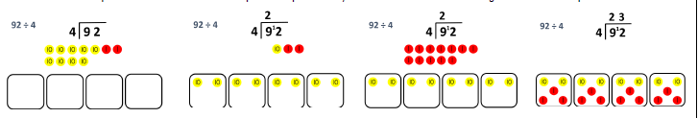

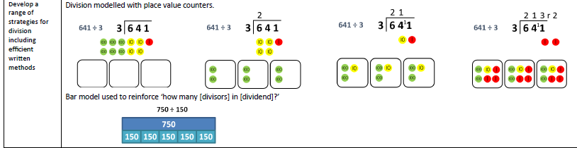

This can then be used as a written procedure without manipulatives:

936 ÷ 3 = 312 is represented as 936 divided into 3 groups.

900 is then divided by 3 (divided into 3 groups: there are 300 in each group.)
30 is divided into by 3 (divided into three groups: there are 10 in each group.)
and 6 is divided by 3 (divided into three groups: there are 2 in each group.)
300+10+2=312

3 1 2
3 9 3 6

Step 6: short division with exchange and no remainders

98 ÷ 7 = 14
90 is divided by 7 (divided into 7 groups: there will be 10 in each group and 20 remaining.)
The 20 is exchanged into ones so there are now 28 ones.
98 is divided by 7 (divided into 7 groups: there are 4 in each group)
10+4=14

1 4
2
7 9 8

Step 7: short division with exchange and remainders

99 ÷ 7 = 14 r 1
90 is divided by 7. This equals 10 and 20 are left over. The 20 is exchanged for 20 ones.
There are now 29 ones. These are divided by 7. This equals 4 and 1 left over.
10+4=14 r 1

1 4 r 1
7 9 29

Step 8: long division (from Mathematics Appendix 1)
This can be demonstrated in a similar way – the process of dividing into groups is the same, the different way of writing it down will need to be demonstrated and practised. Children are encouraged to consider the context of the calculation to decide whether to use decimal places or remainders.
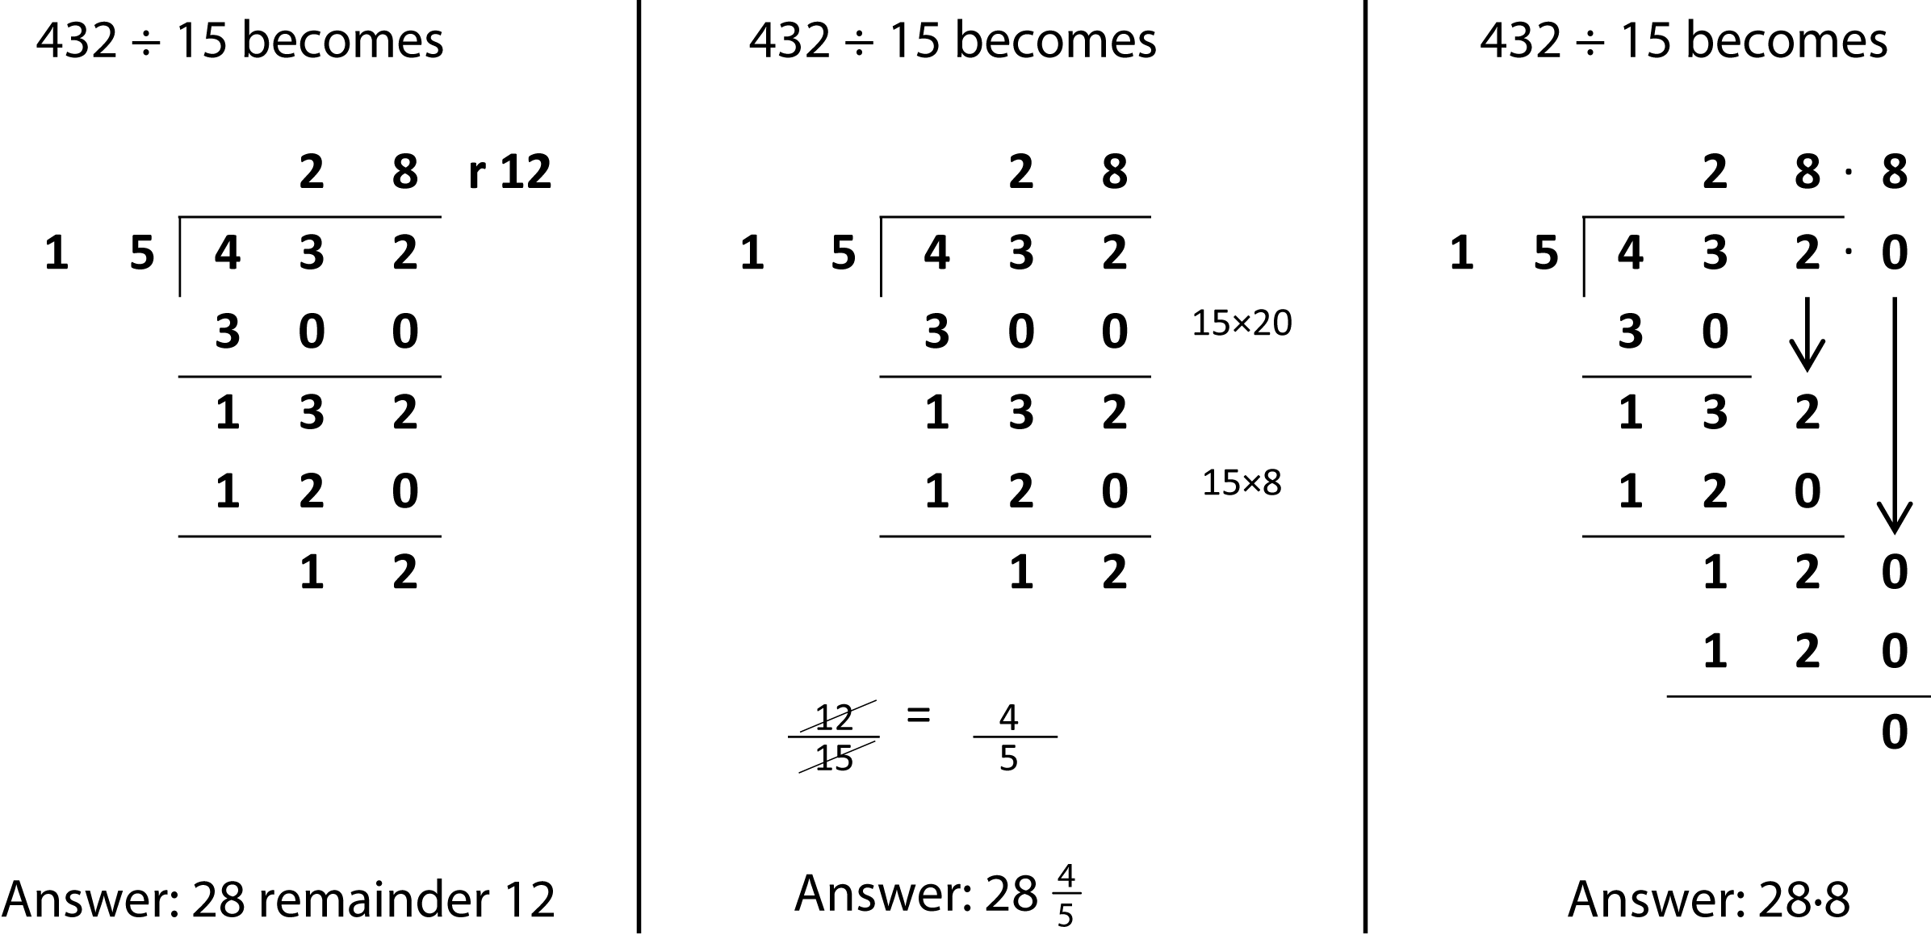

When completing long division calculations, we recommend children make jottings and use a “coin card” (see CLIC) to give them a quick reference to calculate multiples which are larger than their knowledge of tables facts to 12x12.
e.g. a coin card for multiples of 15
10 | 150
5 | 75
2 | 30
1 | 15

